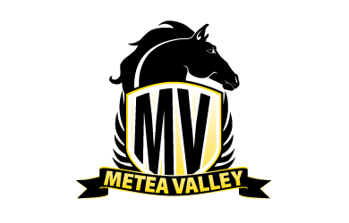
Best Buddies December Outing

November 27, 2017

Dear Parents/Guardians & Best Buddies Members,

Our next outing is planned for Thursday, December 15th. Below is the outline of events for this day:

- We will have a meeting after school from 2:30 - 3:30 p.m.
- Bus will pick up those attending the outing at school at 3:45 p.m
  - Peers who can drive can follow us and not use bus transportation.
- Shopping at the mall from 3:45-5:15
  - Students may bring their own money or just window shop
  - If a student is planning on shopping for Christmas presents and will require assistance, please send in a note explaining who, what, and where the student will be shopping for.
  - Please note that there are not enough adult chaperones to accompany every student attending – the students will be walking around with their peer buddies. Use caution in determining if this is an appropriate event for your student. Those students with the highest needs will be the first priority in determining where adult staff will be allocated.
- Load bus and drive over to Culvers (arrive by 5:25 - 6:00) for dinner (money required)
  - Again, if a student will require assistance ordering their food (due to verbal limitations), please send in a note detailing what his/her order should be (menu can be found online)
- PARENT/GUARDIAN pick up at Culvers at 6:00
  - The bus will NOT be bringing us back to school; pick-up is at Culvers
  - Culvers is on the corner of Route 59 and 75th Street, in front of the Hobby Lobby and next to IHop.

The attached permission slip is due no later than Monday, December 11th. We will not accept any permission slips after this date as we need to plan on correct numbers for the bus and to make groups for the mall.

Best Buddies December Outing Permission Slip

Name of Student: ________________________________________________ ID#______________________

Date of Trip: Thursday, December 14th Time: __3:45-6:00 p.m. ___ Cost: Money for shopping and Culver’s

Destination: Fox Valley Mall & Culver’s Address/City: 195 Fox Valley Center, Aurora, IL 60504
509 State Rd 59, Aurora, IL 60504

Teacher or Staff Member in Charge: Amanda Pyzik & Andrea Lawler Ext. 3943/4522
Type of Transportation: A bus to transport to Fox Valley Mall & Culver’s
My son/daughter WILL attend the outing and WILL take the bus to the mall

PICK-UP Location: Culvers (corner of 59 and 75th Street in Aurora, IL) at 6:00 p.m.

My son/daughter WILL attend the outing but WILL NOT be taking the bus to the mall/Culver’s as they have their own transportation

My son/daughter WILL NOT attend this outing

Parent Name and Contact Number on Day of Trip:
I understand that all school policies will be enforced throughout the duration of this field trip, and the above student has my permission to attend this field trip.
Parent Name:
Contact Number:

___________________________________________________________
(signature of parent/guardian)
*** Permission Slips due Monday, December 11th***

