MC900060297[1]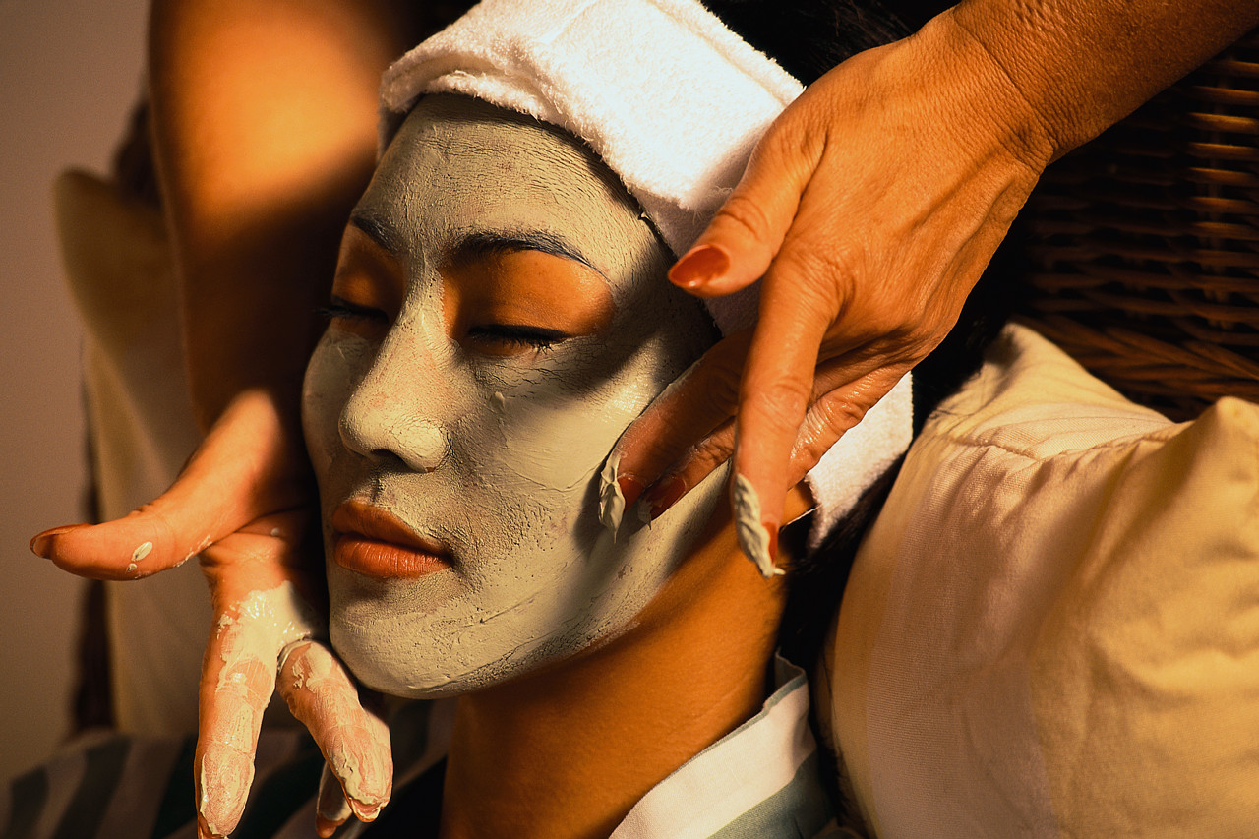[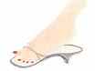](http://images.google.com/imgres?imgurl=http://www.care4yourskin.com/images/categories/36_full.jpg&imgrefurl=http://www.care4yourskin.com/index.php?menuitem=36&h=150&w=200&sz=10&hl=en&start=8&tbnid=bHm_qKQChMDyEM:&tbnh=78&tbnw=104&prev=/images?q=clip+art+pedicure&gbv=2&hl=e)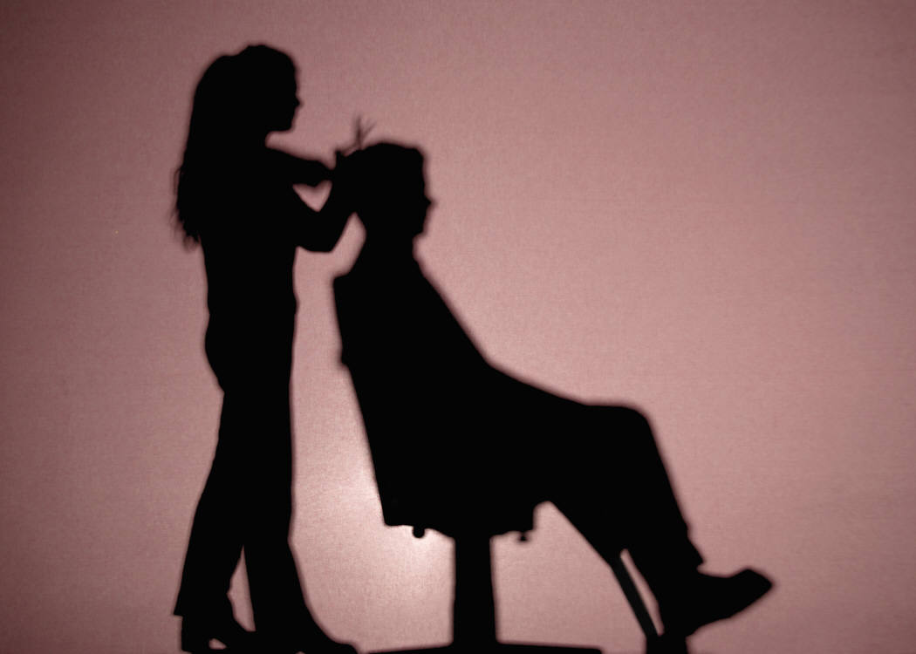

What: Romeoville Best Buddies **Girls’ and Guys’ Afternoon**

* This is an event where girls get the movie star make-overs, while guys get to hang out and play video games as well as participate in any of the activities listed below.

When: Sunday, March 18th, 2018 at 12:30pm-3:00pm

Where: Romeoville High School

100 N Independence Blvd, Romeoville, IL 60446

(Transportation to/from the event is NOT provided from Best Buddies)

COST: $**15.00** **CASH ONLY**

* + $15.00 will include a variety of foods, drinks and any of the following services as well as a goodie bag filled with a generous amount of Ulta products.

Permission Slip & $15.00 are due back by **Thursday, March 8th, 2018.**

Late RSVPs will not be accepted.

**Name: ____________________________________________________________**

**_____ Yes, I can come. ☺ _____ No, I cannot come. ☹**

Please check the things that you would be interested in getting done.

* Please note that all things can be checked, **TIME PERMITTING**. We appreciate your patience and flexibility

I would like to participate in the following stations.

___ Movie and Popcorn

___ Make-up (please come with a clean face free of makeup)

___ Hand Care

___ Nails Painted

___Toe Nails Painted (please make sure that you take old nail polish off your fingers and toes)

___ Facials (please come with no make-up on so you are ready for your facial)

___ Hairstyling – come with CLEAN hair, ready for your cut or style!

___ Hair Cut (Type: ______________________________)

___ Video games

X______________________________________________ ______________________

Parent Signature Date

(We don’t want anyone coming home with any surprises!)

Please note that you are using these products at your own risk. Neither ULTA, nor Best Buddies can be responsible for any adverse reactions.